DATA ENGINEERING PORTFOLIO REPORT

Retail Data Engineering Pipeline
using Python, Medallion Architecture,
and Power BI

Prepared By
Ramesh K N
CMRIT
June 2026

TECHNOLOGIES
Python | Pandas | NumPy | Power BI | Excel | Medallion Architecture | Azure (Future State)

CONFIDENTIAL — FOR EVALUATION AND PORTFOLIO REVIEW PURPOSES ONLY

Table of Contents

Executive Summary
2
1. Introduction
3
1.1 Background
3
1.2 Problem Statement
3
1.3 Objectives
4
2. Project Overview
5
2.1 Technical Perspective
5
2.2 Business Perspective
6
3. Dataset Description
7
3.1 Data Source
7
3.2 Column Schema
8
4. Data Quality Assessment
9
4.1 Identified Data Quality Issues
9
4.2 Impact of Poor Data Quality
10
5. Medallion Architecture
11
5.1 Architecture Overview
11
5.2 Layer Descriptions
12
6. Bronze Layer — Raw Data Ingestion
13
6.1 Layer Purpose
13
6.2 Ingestion Process
13
7. Silver Layer — Data Quality & Transformation
14
7.1 Layer Purpose
14
7.2 Transformation Steps
15
8. Gold Layer — Dimensional Modelling
17
8.1 Layer Purpose
17
8.2 Fact Table: fact_sales
17
9. KPI Engine
21
10. Power BI Dashboard Development
23
11. Business Insights & Strategic Analysis
28
12. Future State — Enterprise Azure Architecture
31
13. Technology Stack
34
14. Challenges Encountered & Solutions Implemented
36
15. Project Outcomes
38
16. Conclusion
40
17. Future Enhancements
42

Executive Summary
This report presents a comprehensive documentation of a professional-grade Data Engineering portfolio project designed to simulate a real-world retail analytics pipeline. The project demonstrates the complete lifecycle of enterprise data engineering — from raw data acquisition and ingestion through structured transformation, dimensional modelling, and business intelligence reporting.
Retail organisations generate substantial volumes of transactional data on a daily basis. However, the inherent quality issues associated with raw operational data — including missing values, duplicate records, invalid entries, and sensitive personally identifiable information — render such data unsuitable for direct analytical consumption. This project addresses these challenges through the implementation of the Medallion Architecture, a well-established data engineering framework that organises data into structured Bronze, Silver, and Gold layers.
The pipeline ingests a retail transactional dataset comprising 8,494 raw records across two primary transaction sheets and a product reference sheet stored in Microsoft Excel format. Through a series of automated Python-based transformation routines leveraging the Pandas and NumPy libraries, the raw dataset is progressively cleansed, standardised, and enriched. Data quality operations include duplicate elimination (494 records), removal of invalid quantity entries (86 records), imputation of missing pricing data, standardisation of product categories and date formats, masking of personally identifiable information, and derivation of revenue metrics.
The final analytical layer (Gold) exposes a dimensional model consisting of fact and dimension tables, alongside pre-aggregated summary datasets. These datasets serve as the primary data source for a suite of five interactive Power BI dashboards — covering executive performance summaries, revenue trend analysis, product performance benchmarking, category analytics, and regional sales distribution.

Total Revenue  INR 1.16 B | Total Orders  7,914 | Customers  1,960 | Avg Order Value  INR 147,080 | Top City  Chennai

Figure ES-1: Key Performance Indicators – Project Outcomes Summary
The project delivers significant business value by providing retail stakeholders with a reliable, governed, and scalable analytical foundation. It replaces fragmented manual reporting with an automated, repeatable pipeline that enforces data quality standards and enables data-driven decision-making at both operational and strategic levels. The architecture is designed with future scalability in mind, with a clearly defined pathway for migration to an enterprise Azure cloud environment encompassing Azure Data Lake Gen2, Azure Data Factory, Azure Databricks, and Azure SQL Database.
This report serves as a technical reference document and professional portfolio artefact demonstrating proficiency across the full data engineering spectrum, including data ingestion design, data quality engineering, dimensional modelling, KPI derivation, dashboard development, and cloud architecture planning.

1. Introduction

1.1 Background
The global retail sector is undergoing a fundamental transformation driven by the proliferation of digital transactions, e-commerce platforms, and omnichannel retail operations. Modern retail organisations generate vast quantities of transactional data across multiple touchpoints — point-of-sale systems, online marketplaces, loyalty programmes, and inventory management systems — at an unprecedented scale and velocity.
According to industry estimates, global retail data volumes are growing at a compound annual rate exceeding 30%, creating both significant opportunities and formidable challenges for organisations seeking to leverage data as a strategic asset. The ability to transform raw transactional data into actionable business intelligence has become a critical competitive differentiator, enabling organisations to optimise pricing strategies, personalise customer experiences, streamline supply chain operations, and identify emerging market trends.
Data engineering forms the foundational discipline that bridges raw data generation and analytical insight delivery. It encompasses the design, construction, and maintenance of data pipelines, data quality frameworks, and analytical data stores that ensure data is accurate, complete, consistent, and readily accessible to business stakeholders. Without robust data engineering foundations, analytical outputs are unreliable and business decisions risk being based on erroneous information.
This project responds to the growing demand for data engineering expertise within the retail sector by constructing an end-to-end analytical pipeline that mirrors the design patterns, quality standards, and architectural principles employed in enterprise-grade production environments.

1.2 Problem Statement
Retail organisations accumulate large volumes of transactional data through daily operations. While the volume of this data represents a significant informational asset, its inherent quality limitations severely constrain its analytical utility in its raw form. The following challenges are characteristic of retail transactional data environments:
- Missing Values: Critical fields such as product pricing are frequently absent due to system integration gaps, manual data entry errors, or synchronisation failures between point-of-sale and inventory management systems.
- Duplicate Transactions: Data consolidation from multiple operational sources commonly results in duplicate records, inflating reported transaction volumes and distorting revenue calculations.
- Data Inconsistencies: Categorical fields such as product categories are often populated inconsistently across source systems, reflecting differences in naming conventions, capitalisation standards, or encoding practices.
- Temporal Inconsistencies: Transaction date fields may be recorded in varying formats across source systems, creating complications for time-series analysis and period-based reporting.
- Invalid Data Entries: Operational errors result in records containing illogical values, such as negative quantities or zero-value transactions, which corrupt analytical outputs.
- Data Privacy Concerns: Retail datasets routinely contain personally identifiable information (PII) including customer names, email addresses, and telephone numbers that require appropriate masking before analytical use in compliance with data protection regulations.
- Fragmented Data Sources: Transaction data is frequently distributed across multiple files or database tables that require consolidation before analysis can proceed.
Collectively, these data quality challenges undermine the reliability of business reporting and prevent organisations from extracting meaningful, trustworthy insights from their data assets. The absence of a structured data engineering pipeline perpetuates a cycle of manual, ad-hoc data manipulation that is error-prone, non-repeatable, and operationally inefficient.

1.3 Objectives
The primary objectives of this project are as follows:
- To design and implement a structured Medallion Architecture data pipeline that organises retail transactional data into Bronze, Silver, and Gold processing layers.
- To develop automated Python-based data ingestion routines capable of reading and consolidating retail data from multiple Excel source files.
- To engineer comprehensive data quality transformation logic addressing missing values, duplicate records, categorical inconsistencies, temporal standardisation, and invalid data entries.
- To implement data privacy controls through systematic masking of personally identifiable information fields prior to analytical processing.
- To construct a dimensional data model in the Gold layer, incorporating fact tables, dimension tables, and pre-aggregated summary datasets optimised for business intelligence consumption.
- To derive and validate a set of business-critical Key Performance Indicators (KPIs) including total revenue, order volume, customer count, and average order value.
- To develop a suite of five interactive Power BI dashboards delivering executive, revenue, product, category, and regional analytical perspectives.
- To document a future-state enterprise architecture on Microsoft Azure that provides a scalable, cloud-native evolution pathway for the pipeline.
- To produce a comprehensive professional report suitable for submission to corporate data engineering review boards, hiring managers, and academic evaluators.

2. Project Overview
This project constructs a complete, enterprise-style end-to-end retail analytics pipeline that transforms raw operational transaction data into structured, governed, and analytically ready datasets, culminating in the delivery of interactive business intelligence dashboards. The pipeline is engineered in accordance with professional data engineering standards, employing the Medallion Architecture as its core organisational framework.

2.1 Technical Perspective
From a technical standpoint, the pipeline is implemented in Python, leveraging the Pandas library for all data manipulation and transformation operations and NumPy for numerical computations and vectorised operations. The pipeline follows a structured, layered approach:
- Bronze Layer: Raw data is ingested directly from Microsoft Excel source files without modification, preserving the integrity and lineage of the original source data. The Bronze layer serves as the immutable historical record of all raw data received.
- Silver Layer: Comprehensive data quality engineering is applied, including dataset merging, deduplication, missing value treatment, categorical standardisation, temporal normalisation, invalid record filtering, PII masking, and revenue derivation. The output is a clean, validated, analysis-ready dataset.
- Gold Layer: Dimensional modelling transforms the cleansed Silver dataset into a structured star schema comprising fact tables, dimension tables, and pre-aggregated reporting tables, optimised for Power BI consumption.
- KPI Engine: A dedicated analytical module computes enterprise-level Key Performance Indicators from the Gold layer datasets, providing a standardised set of business metrics.
- Power BI Dashboards: Five interactive dashboards are developed on top of the Gold layer, delivering multi-perspective analytical views for executive, commercial, product, category, and regional stakeholders.

2.2 Business Perspective
From a business perspective, the project delivers a governed analytical platform that enables retail decision-makers to transition from anecdotal, intuition-based decision-making to evidence-based strategic management. The pipeline provides:
- A single, trusted source of retail performance data, eliminating inconsistencies between departmental reports.
- Automated, repeatable analytical outputs that reduce reliance on manual data processing and the associated risk of human error.
- Standardised KPI definitions that ensure consistent performance measurement across the organisation.
- Interactive dashboards that enable self-service exploration of retail performance across product, category, city, and time dimensions.
- A documented, scalable architecture that provides a clear migration pathway to an enterprise cloud environment as data volumes and analytical demands grow.

3. Dataset Description

3.1 Data Source
The dataset utilised in this project is a retail transactional dataset stored in Microsoft Excel format (.xlsx). The file contains three worksheets representing distinct aspects of the retail operation: product reference data, primary transaction records (Batch 1), and transaction records from a secondary data capture period (Batch 2).
File Format: Microsoft Excel Workbook (.xlsx)
Number of Worksheets: 3
Total Raw Transaction Records: 8,494

Worksheet Name | Rows | Columns | Description
product_details | 10 | 4 | Product reference master with ID, name, category, and price
retail_data1 | 4,243 | 16 | Primary batch of retail transaction records
retail_data2 | 4,251 | 16 | Secondary batch of retail transaction records
TOTAL | 8,504 | — | Combined raw dataset prior to deduplication
Table 3.1: Dataset Summary — Worksheet Structure and Record Counts

3.2 Column Schema
The following table documents all data fields present in the retail transaction worksheets (retail_data1 and retail_data2):

Column Name | Data Type | Nullable | Description
transaction_id | String | No | Unique identifier for each retail transaction
customer_id | String | No | Unique identifier assigned to each customer
customer_name | String | Yes | Full name of the transacting customer (PII)
product_id | String | No | Unique identifier for the purchased product
price | Float | Yes | Unit selling price of the product (INR)
product_name | String | Yes | Name/description of the purchased product
category | String | Yes | Product category classification
city | String | Yes | City where the transaction occurred
transaction_date | Date/String | Yes | Date on which the transaction was recorded
quantity | Integer | Yes | Number of units purchased in the transaction
payment_method | String | Yes | Mode of payment (e.g., Cash, Card, UPI)
discount | Float | Yes | Discount percentage applied to the transaction
email | String | Yes | Customer email address (PII)
phone | String | Yes | Customer telephone number (PII)
payment_status | String | Yes | Status of payment (Completed / Pending / Failed)
Table 3.2: Retail Transaction Column Schema

4. Data Quality Assessment
A thorough data quality assessment was conducted on the raw dataset prior to the commencement of transformation activities. The assessment identified multiple categories of data quality defects that, if left unaddressed, would materially compromise the accuracy and reliability of all downstream analytical outputs.

4.1 Identified Data Quality Issues

Issue Category | Affected Field(s) | Severity | Business Impact
Missing Prices | price | HIGH | Revenue calculations return null/zero; products cannot be valued
Duplicate Transactions | transaction_id | HIGH | Inflates order counts and total revenue figures (494 duplicates identified)
Invalid Quantities | quantity | HIGH | Negative or zero quantity values make revenue computation meaningless (86 records)
Category Inconsistencies | category | MEDIUM | Inconsistent casing/abbreviations prevent accurate category-level aggregation
Date Format Inconsistencies | transaction_date | MEDIUM | Mixed date formats prevent time-series analysis and period filtering
Exposed PII — Email | email | HIGH | Customer email addresses exposed; violates data privacy obligations
Exposed PII — Phone | phone | HIGH | Customer telephone numbers exposed; regulatory compliance risk
Dataset Fragmentation | All fields | MEDIUM | Data split across two sheets requiring consolidation before analysis
Table 4.1: Data Quality Issue Assessment Matrix

4.2 Impact of Poor Data Quality
The downstream consequences of failing to address these data quality issues would include the following:
- Revenue Misstatement: Duplicate transactions and invalid quantities, if not corrected, would result in a material overstatement of total revenue figures, potentially by hundreds of millions of rupees, rendering KPI reporting entirely unreliable.
- Erroneous Segmentation: Category inconsistencies would result in the fragmentation of product categories into multiple spurious groups, distorting revenue distribution analysis and misrepresenting category performance rankings.
- Temporal Analysis Failure: Inconsistent date formats would prevent the construction of reliable monthly revenue trend charts, eliminating one of the most valuable business intelligence capabilities.
- Regulatory Exposure: Retention and exposure of unmasked PII in analytical environments would create significant regulatory risk under applicable data protection legislation, with potential penalties for non-compliance.
- Stakeholder Trust Erosion: Presentation of analytically derived insights to senior stakeholders based on uncleansed data would erode confidence in the data engineering function and the broader analytics programme.
These findings underscore the critical importance of the Silver Layer transformation process described in Section 6 of this report.

5. Medallion Architecture

5.1 Architecture Overview
The Medallion Architecture, also known as the Multi-Hop Architecture or Lakehouse Architecture pattern, is a data design paradigm that organises data assets into three progressively refined processing layers: Bronze, Silver, and Gold. This architecture was originally formalised by Databricks and has since been widely adopted as a best-practice framework for data lake and lakehouse implementations across the industry.
The fundamental principle of the Medallion Architecture is progressive data quality enhancement. Data moves through each layer in a unidirectional flow, with each transition adding value through increased quality, structure, and analytical readiness. At no point are downstream transformations applied retroactively to upstream layers, ensuring complete data lineage and auditability.

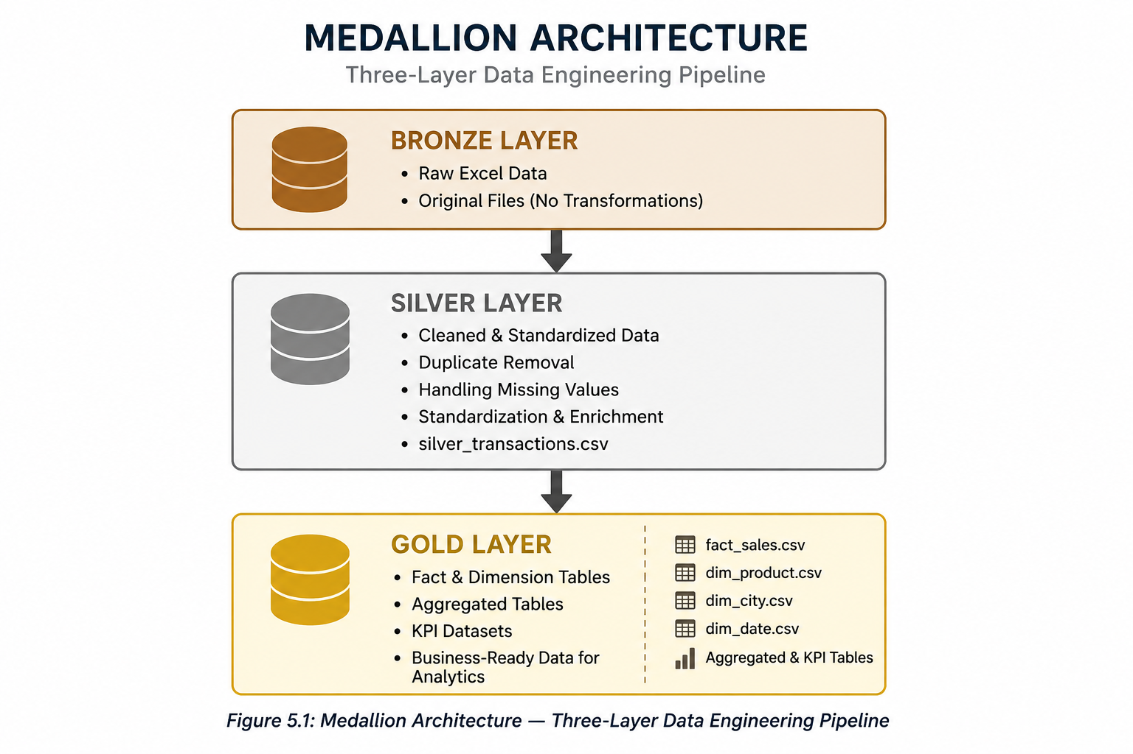

Figure 5.1: Medallion Architecture — Three-Layer Data Engineering Pipeline

5.2 Layer Descriptions
Layer | Quality Level | Content | Primary Consumers
Bronze | Raw / Unprocessed | Exact copy of source data; no transformations applied | Data Engineers, Audit/Lineage Tracing
Silver | Cleansed / Validated | Deduped, standardised, PII-masked, enriched analytical dataset | Data Analysts, ML Engineers
Gold | Curated / Aggregated | Dimensional model: fact tables, dims, aggregated reporting tables | Business Users, Power BI, Reporting Tools
Table 5.1: Medallion Architecture Layer Comparison

The adoption of the Medallion Architecture for this project delivers several strategic benefits:
- Separation of Concerns: Each layer has a clearly defined purpose and ownership boundary, preventing transformation logic from becoming entangled with ingestion or serving concerns.
- Data Lineage and Auditability: The immutability of the Bronze layer ensures that the complete history of raw source data is preserved, enabling full traceability from any analytical result back to its originating source record.
- Incremental Processing: The layered structure facilitates incremental data processing in production environments, enabling efficient handling of new data arrivals without full pipeline re-execution.
- Failure Isolation: Data quality failures in the Silver layer do not corrupt the Bronze source, enabling re-processing from a reliable checkpoint.
- Scalability: The architecture scales naturally from local file-based implementations to enterprise cloud deployments on platforms such as Azure Data Lake, Databricks, or AWS Lake Formation.

6. Bronze Layer — Raw Data Ingestion

6.1 Layer Purpose
The Bronze layer constitutes the entry point of the data engineering pipeline. Its primary function is the faithful ingestion and preservation of source data in its original, unmodified form. The Bronze layer operates on the principle of data immutability: once data is written to the Bronze layer, it is never modified or deleted. This immutability is a fundamental data governance requirement that ensures complete data lineage, enables auditability of all analytical outputs, and provides a reliable recovery point in the event of downstream processing failures.
In enterprise implementations, Bronze layer data is typically stored in a data lake (such as Azure Data Lake Gen2 or AWS S3) in its raw format, often as Parquet files with minimal schema enforcement. For this project, the Bronze layer is implemented as a local file store containing the original Excel source files alongside a preserved copy of the ingested data, maintaining the structural fidelity of the source system.

6.2 Ingestion Process
The Bronze layer ingestion process for this project encompasses the following steps:
- Source File Identification: The Excel workbook is identified and validated for accessibility.
- Worksheet Enumeration: All three worksheets (product_details, retail_data1, retail_data2) are enumerated and individually read using the Pandas read_excel() function.
- Schema Capture: Column names, data types, and record counts are logged for each worksheet to establish an ingestion audit trail.
- Raw Storage: Each worksheet's data is preserved as a raw dataset without any type coercion, filtering, or transformation.
- Ingestion Metadata: Metadata records are created capturing the ingestion timestamp, source file name, worksheet name, and row count for each ingested dataset.
The Bronze layer serves as the single source of truth for all subsequent processing. Any re-processing of the Silver or Gold layers begins from the Bronze source data, ensuring that transformation logic improvements can be applied retrospectively without data loss.

7. Silver Layer — Data Quality & Transformation

7.1 Layer Purpose
The Silver layer is responsible for all data quality engineering activities within the pipeline. It receives raw data from the Bronze layer and produces a cleansed, validated, standardised, and analytically coherent dataset that is safe for consumption by downstream dimensional modelling and reporting processes. The Silver layer transformation process is the most technically complex stage of the pipeline, encompassing eight distinct transformation categories applied in a carefully sequenced order to ensure that each operation produces the expected result.

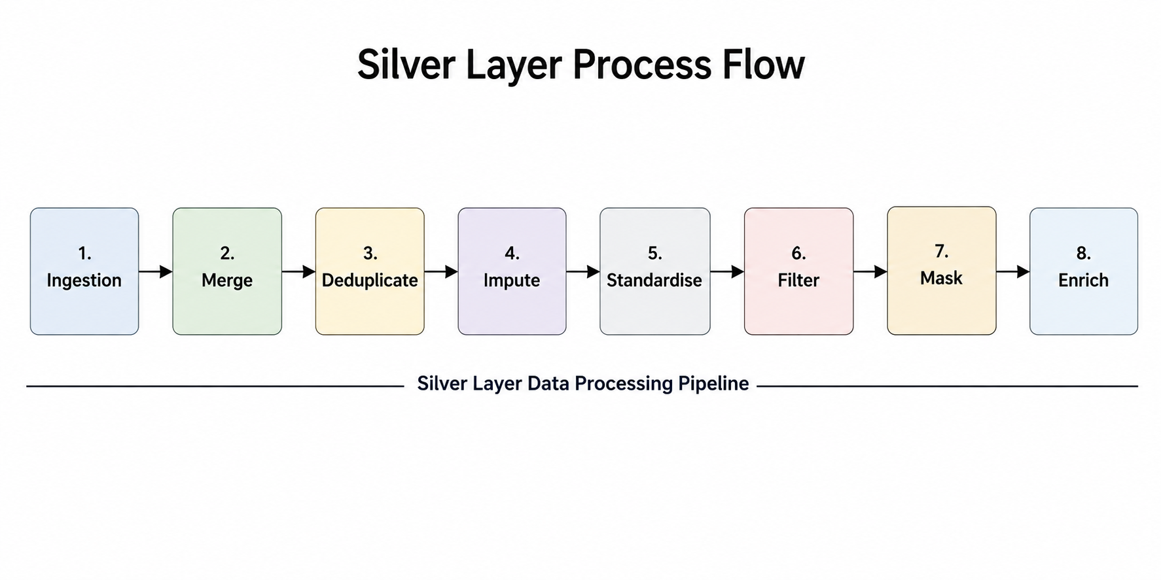
Figure 7.1: Silver Layer Transformation Process Flow

7.2 Transformation Steps

Step 1: Dataset Merging
The two retail transaction worksheets (retail_data1 and retail_data2) represent data captured across different operational periods. These datasets share an identical column schema and must be vertically consolidated prior to any quality processing. Using Pandas' concat() function with ignore_index=True, the two transaction sheets are combined to produce a unified dataset of 8,494 records.
The product_details reference table is subsequently left-joined to the consolidated transaction dataset on the product_id key field. This join enriches transaction records with authoritative product master data — specifically, the canonical product_name, category classification, and standard price — sourced from the product reference system.

Step 2: Duplicate Record Elimination
Duplicate detection is performed on the transaction_id field, which is designated as the primary natural key of the transaction dataset. Using Pandas' drop_duplicates() function with the subset parameter scoped to transaction_id and the keep='first' strategy, all records subsequent to the first occurrence of any given transaction identifier are removed from the dataset.
This operation identified and eliminated 494 duplicate records from the consolidated dataset, representing a 5.82% duplication rate — a material quality defect that would have significantly inflated all reported revenue and volume metrics had it not been addressed.

Step 3: Missing Price Imputation
A subset of transaction records contains null or missing values in the price field, attributable to synchronisation failures between the transactional system and the product pricing master. To address this, missing prices are imputed using the authoritative unit price from the product_details reference table, joined by product_id. Where a reference price is available, it replaces the null value. Where no reference price exists, records are flagged for review rather than imputed with an arbitrary value, preserving data integrity.

Step 4: Product Category Standardisation
Analysis of the category field revealed significant inconsistency in how product categories were recorded across source systems. Variations including differences in capitalisation, abbreviations, and whitespace handling resulted in what should be a single category appearing as multiple distinct values. A standardisation mapping is applied using Pandas' str.strip() and str.title() functions, supplemented by an explicit value mapping dictionary that resolves known variant spellings to their canonical forms. This consolidation ensures accurate and consistent category-level revenue aggregation.

Step 5: Transaction Date Standardisation
The transaction_date field was populated using inconsistent date formats across the two source worksheets, reflecting differences in the data entry conventions of the operational systems from which the data was extracted. Pandas' to_datetime() function is applied with infer_datetime_format=True and errors='coerce' parameters, converting all parseable date strings to a standardised datetime64 representation. Records with unparseable date values are isolated for investigation. A standardised string representation in ISO 8601 format (YYYY-MM-DD) is applied for consistent downstream processing.

Step 6: Invalid Quantity Filtering
Business logic validation is applied to the quantity field, which must contain a positive integer value to represent a valid transaction. Records containing a quantity value of zero or below are semantically invalid — they cannot represent a genuine retail purchase — and are therefore excluded from the analytical dataset. This operation removes 86 records, which represents 1.04% of the post-deduplication dataset.

Step 7: PII Masking
In compliance with data protection principles and to ensure the dataset is safe for use in analytical environments, personally identifiable information fields are masked before any data is exposed to analytical consumers. Two PII fields are treated:
- Email Masking: Customer email addresses are partially masked such that only the domain component is preserved (e.g., user@example.com becomes ***@example.com). This preserves analytical utility for domain-level analysis whilst protecting the individual identity of the customer.
- Phone Number Masking: Customer telephone numbers are masked such that only the last three digits are visible, with all preceding digits replaced by asterisks (e.g., 9876543210 becomes *******210). This format preserves the numeric structure for format validation whilst rendering the number non-identifiable.

Step 8: Revenue Derivation
A derived metric column, revenue, is calculated for each transaction record using the formula:
revenue = price × quantity × (1 - discount / 100)
This formula incorporates the effect of any applicable discount on the final transaction revenue value. The derived revenue column forms the primary metric for all subsequent aggregation, KPI computation, and dashboard visualisation.

7.3 Silver Layer Output Statistics

Processing Stage | Records | Notes
Raw Input (retail_data1 + retail_data2) | 8,494 | Combined from two Excel worksheets
After Duplicate Removal | 8,000 | 494 duplicate transaction_id records removed
After Invalid Quantity Filtering | 7,914 | 86 records with quantity <= 0 removed
Final Silver Dataset | 7,914 | Clean, validated, PII-masked analytical dataset
Table 7.1: Silver Layer Record Count Progression

8. Gold Layer — Dimensional Modelling

8.1 Layer Purpose
The Gold layer represents the final and most refined stage of the data pipeline. It consumes the cleansed Silver dataset and transforms it into a structured dimensional model optimised for business intelligence consumption. The Gold layer employs a star schema design pattern, organising data into a central fact table surrounded by dimension tables that provide descriptive context for analytical queries.
In addition to the core dimensional model, the Gold layer generates a series of pre-aggregated reporting tables that encapsulate common analytical computations, enabling Power BI dashboards to perform rapid visualisation without requiring complex runtime aggregation over the full dataset.

8.2 Fact Table: fact_sales
The fact_sales table constitutes the central analytical entity in the Gold layer star schema. It contains one record per validated retail transaction and serves as the primary source for all revenue and volume measurements. The fact table is designed to be narrow and metric-focused, with foreign key references to all relevant dimension tables.
Column | Type | Description
transaction_id | VARCHAR | Natural key — unique transaction identifier
customer_id | VARCHAR | Foreign key to dim_customer (if implemented)
product_id | VARCHAR | Foreign key to dim_product
city | VARCHAR | Foreign key to dim_city
transaction_date | DATE | Foreign key to dim_date
quantity | INTEGER | Units purchased
price | DECIMAL | Unit price at time of transaction (INR)
discount | DECIMAL | Discount percentage applied
revenue | DECIMAL | Derived: price x quantity x (1 - discount/100)
payment_method | VARCHAR | Mode of payment
payment_status | VARCHAR | Transaction payment status
Table 8.1: fact_sales — Column Definitions

8.3 Dimension Tables

dim_product
The product dimension table contains one record per unique product, providing the descriptive attributes required for product-level analytical slicing and filtering.
Column | Type | Description
product_id | VARCHAR PK | Unique product identifier
product_name | VARCHAR | Canonical product name
category | VARCHAR | Standardised product category
standard_price | DECIMAL | Reference unit price (INR)
Table 8.2: dim_product — Column Definitions

dim_city
The city dimension provides a reference table for geographic analytical dimensions.
Column | Type | Description
city_id | INTEGER PK | Surrogate key
city_name | VARCHAR | Name of the city
state | VARCHAR | State (if applicable)
Table 8.3: dim_city — Column Definitions

dim_date
The date dimension enables rich temporal analysis across multiple calendar hierarchies.
Column | Type | Description
date_id | DATE PK | Full date value (YYYY-MM-DD)
year | INTEGER | Calendar year
quarter | INTEGER | Calendar quarter (1–4)
month | INTEGER | Calendar month (1–12)
month_name | VARCHAR | Month name (e.g., January)
week_number | INTEGER | ISO week number
day_of_week | VARCHAR | Day name (e.g., Monday)
Table 8.4: dim_date — Column Definitions

8.4 Aggregated Reporting Tables
The following pre-aggregated tables are generated in the Gold layer to support efficient Power BI dashboard rendering:
Table Name | Granularity | Key Metrics
monthly_revenue.csv | Year + Month | Total revenue, order count, avg order value per month
revenue_by_city.csv | City | Total revenue, order count, revenue share % per city
revenue_by_category.csv | Category | Total revenue, order count, revenue share % per category
top_products.csv | Product | Total revenue, total units sold, revenue rank per product
Table 8.5: Gold Layer — Pre-Aggregated Reporting Tables

9. KPI Engine

9.1 Overview
The KPI Engine is a dedicated Python module that computes a standardised set of enterprise-level Key Performance Indicators from the Gold layer analytical datasets. These KPIs provide business stakeholders with an instantaneous, quantitative summary of the organisation's retail performance and serve as the headline metrics displayed on the Executive Summary Power BI dashboard.
The KPI computation logic is designed to be deterministic and reproducible — given the same Gold layer input datasets, the KPI Engine will always produce identical outputs. This determinism is a critical property for a business-facing KPI suite, as it ensures that KPI values reported in dashboards are always consistent with the underlying data.

9.2 Computed KPIs

KPI Name | Value | Computation | Business Significance
Total Revenue | INR 1.16 Billion | SUM(revenue) | Primary performance indicator; measures aggregate monetary value of all completed transactions
Total Orders | 7,914 | COUNT(transaction_id) | Indicates overall transaction volume and market activity level after quality filtering
Total Customers | 1,960 | COUNT(DISTINCT customer_id) | Measures unique customer reach; informs customer acquisition and retention strategy
Average Order Value | INR 147,080 | Total Revenue / Total Orders | Indicates average transaction size; key metric for pricing and product mix strategy
Top Product | Laptop | MAX revenue by product_name | Identifies the single highest-revenue product; informs inventory and marketing prioritisation
Top City | Chennai | MAX revenue by city_name | Identifies the highest-performing geographic market; informs regional investment decisions
Table 9.1: KPI Engine — Computed Key Performance Indicators

The high Average Order Value of INR 147,080 is a particularly significant finding. This figure suggests that the retail operation is characterised by high-value, infrequent transactions rather than high-volume, low-value purchases — a pattern consistent with a product mix dominated by premium electronics and technology goods. This insight has direct implications for sales strategy, customer relationship management, and inventory financing.

10. Power BI Dashboard Development
The Power BI dashboard suite constitutes the primary business-facing output of the data engineering pipeline. Five purpose-built dashboards are developed, each targeting a distinct analytical perspective and stakeholder audience. All dashboards consume data exclusively from the Gold layer outputs, ensuring that the displayed information reflects the cleansed, validated, and standardised data that has passed through the full pipeline quality process.
The dashboard design philosophy prioritises clarity, information density, and actionability. Each dashboard follows a consistent visual language — employing the corporate blue colour palette, standardised chart types, and a hierarchical information layout that presents headline KPIs at the top and supporting analytical detail below.

10.1 Executive Summary Dashboard
The Executive Summary Dashboard is designed for senior leadership consumption and provides a holistic overview of retail performance across all key dimensions. It is the primary landing page of the Power BI report and is intended to be the first view encountered by any stakeholder accessing the analytical platform.
The dashboard incorporates the following analytical elements:
- Total Revenue KPI Card: Displays the overall revenue figure with period-over-period comparison indicators, providing an immediate assessment of commercial performance.
- Total Orders KPI Card: Shows the total volume of validated transactions, enabling leaders to distinguish between revenue growth driven by volume versus price/mix changes.
- Total Customers KPI Card: Presents the unique customer count, supporting customer base growth tracking and market penetration assessment.
- Average Order Value KPI Card: Highlights the average transaction size, a critical metric for evaluating the commercial effectiveness of pricing strategies.
- Revenue by Category: A horizontal bar chart segmenting total revenue across all product categories, enabling rapid identification of the highest-value product segments.
- Revenue by City: A geographic bar chart displaying revenue contribution by city, supporting regional performance benchmarking.

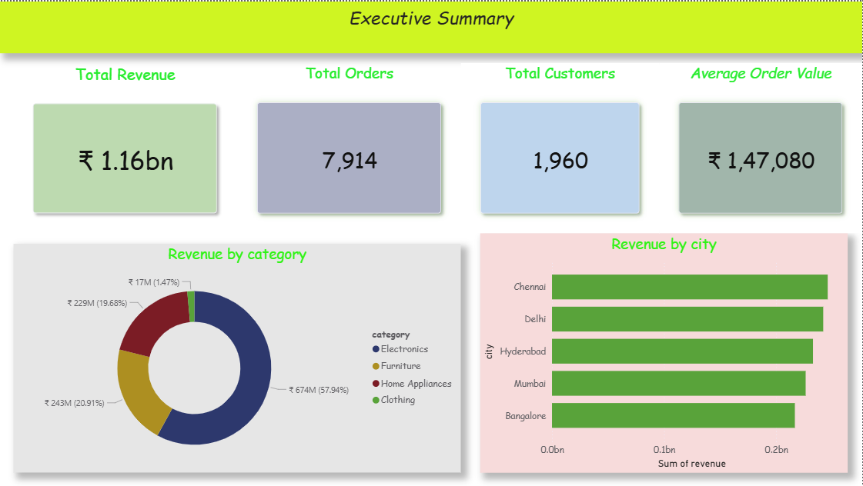
Figure 10.1: Power BI Executive Summary Dashboard

10.2 Revenue Trends Dashboard
The Revenue Trends Dashboard provides a temporal analytical view of retail performance, enabling stakeholders to identify revenue trends, seasonal patterns, growth trajectories, and period-specific anomalies. This dashboard is primarily consumed by commercial and financial planning teams.
- Monthly Revenue Trend Line Chart: Plots total monthly revenue across the full analytical period, revealing the temporal revenue trajectory and highlighting seasonal peaks and troughs.
- Revenue by City Bar Chart: A comparative bar chart presenting city-level revenue performance for the selected analytical period.
- Revenue Summary Table: A detailed data table providing month-by-month revenue, order count, and average order value figures for precision reference alongside the visual representations.

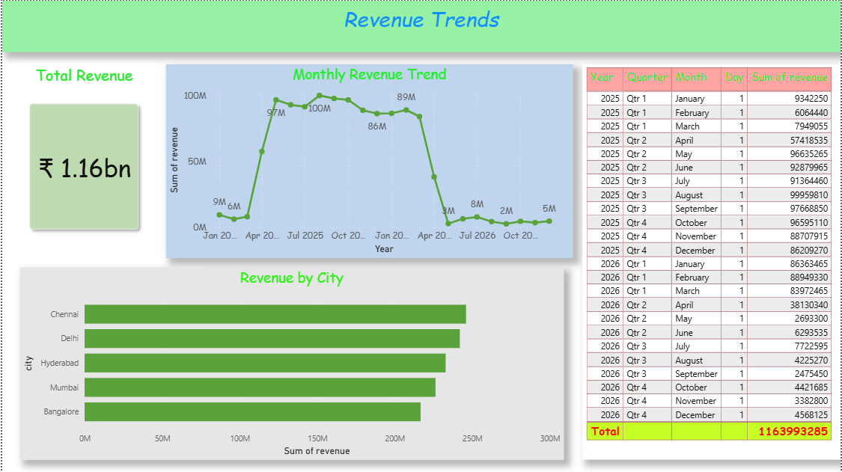
Figure 10.2: Power BI Revenue Trends Dashboard

10.3 Product Performance Dashboard
The Product Performance Dashboard provides a product-level analytical view, enabling commercial teams to identify the highest and lowest-performing products, understand revenue concentration, and make informed decisions about product investment, pricing, and discontinuation.
- Top Products by Revenue Bar Chart: Ranks all products by total revenue generated, immediately identifying the portfolio's commercial anchors.
- Product Revenue Distribution Donut Chart: Visualises the revenue share of each product as a proportion of total portfolio revenue, highlighting concentration risk.
- Maximum Revenue KPI Card: Highlights the single highest-revenue product (Laptop) with its revenue contribution value.

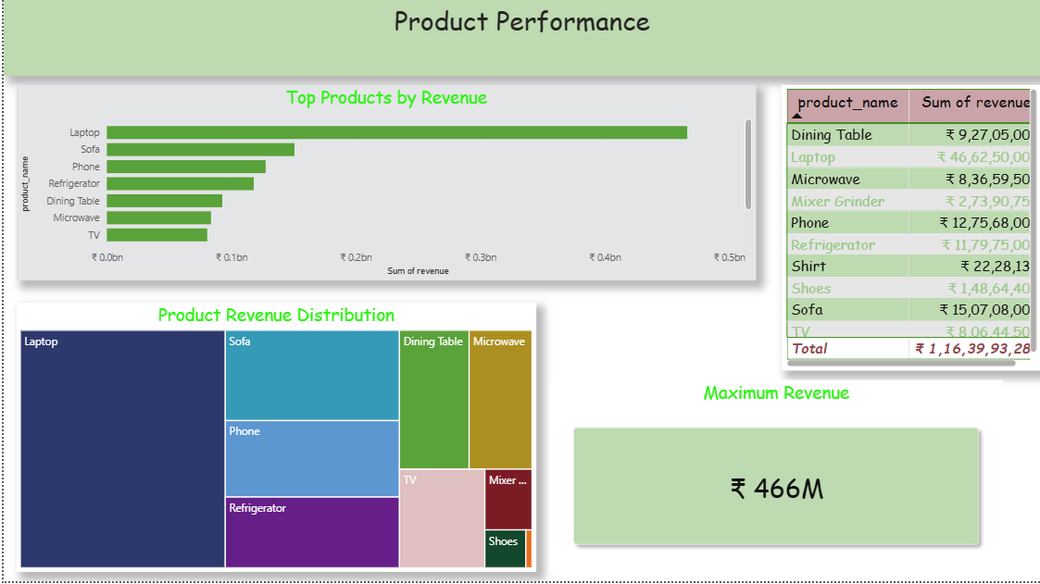
Figure 10.3: Power BI Product Performance Dashboard

10.4 Category Analysis Dashboard
The Category Analysis Dashboard aggregates product-level performance to the category level, providing strategic insights into which product segments are driving the business and how revenue is distributed across the category portfolio.
- Category Performance Comparison Bar Chart: Provides a comparative view of revenue performance across all product categories.
- Revenue Contribution by Category Donut Chart: Illustrates the revenue share of each category, identifying which categories represent the greatest commercial concentration.
- Category Revenue Distribution Table: A detailed reference table providing category-level revenue, order count, unit volume, and average selling price.

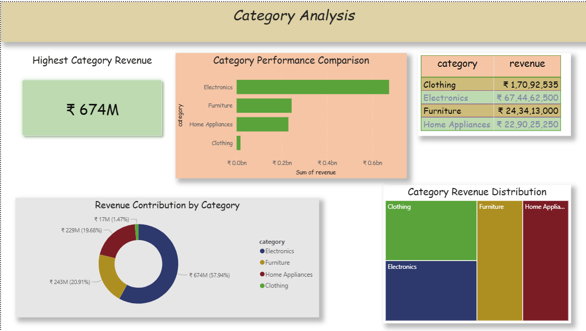
Figure 10.4: Power BI Category Analysis Dashboard

10.5 Regional Analysis Dashboard
The Regional Analysis Dashboard provides a geographic perspective on retail performance, enabling strategic decisions about regional market investment, sales force deployment, and geographic expansion planning.
- Top Performing City KPI Card: Highlights Chennai as the highest-revenue geographic market with its total revenue contribution.
- Revenue by City Bar Chart: Comparative bar chart ranking all cities by total revenue generated across the analytical period.
- Revenue Share by City Donut Chart: Pie/donut visualisation showing each city's percentage contribution to total revenue.

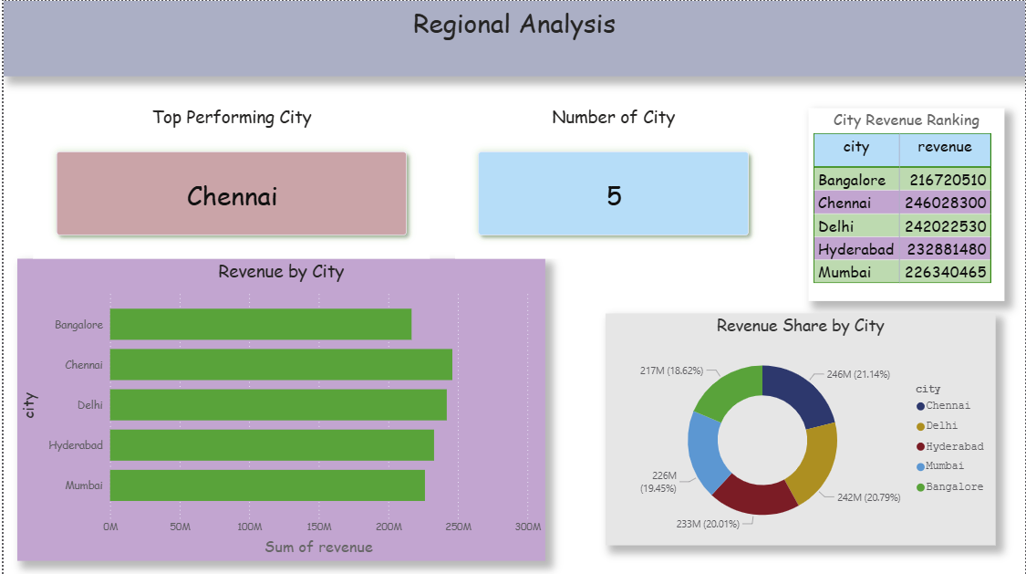
Figure 10.5: Power BI Regional Analysis Dashboard

11. Business Insights & Strategic Analysis
The following business insights are derived from the KPI Engine outputs and Power BI dashboard analytics. These insights represent actionable intelligence that retail decision-makers can leverage to drive strategic and operational improvements.

11.1 Revenue Concentration in Electronics
The data reveals a pronounced concentration of revenue within the Electronics product category, which generates a disproportionately large share of total pipeline revenue. This finding has several strategic implications:
- The Electronics category should be designated as a strategic priority category, warranting dedicated inventory investment, promotional support, and sales specialist resourcing.
- Revenue concentration within a single category creates structural business risk. The organisation should evaluate opportunities to drive growth in adjacent categories (e.g., Home Appliances, Computers) to reduce dependency on Electronics performance.
- Pricing strategy reviews within the Electronics category may yield significant revenue impacts given the category's high contribution to total revenue.

11.2 Chennai as the Dominant Geographic Market
Chennai consistently emerges as the highest-revenue city across the analytical period, suggesting the presence of a large, high-spending customer base in the Chennai metropolitan area. Strategic recommendations:
- Consider increasing inventory depth and product assortment breadth in Chennai retail locations to capitalise on demonstrated demand.
- Evaluate the feasibility of dedicating specific marketing campaigns and promotional events to the Chennai market given its outsized revenue contribution.
- Investigate the customer segments driving Chennai's performance to understand whether the revenue is concentrated among a small number of high-value accounts or distributed across a broad customer base.

11.3 Laptop as the Highest-Revenue Product
The Laptop product category generates the maximum revenue of any individual product in the portfolio. This finding is consistent with the overall Electronics category dominance and the high Average Order Value observed across the dataset. Operational implications:
- Laptop stock management should be treated as a critical operational priority, as stockout events would have a material adverse impact on overall revenue performance.
- The high average selling price of laptops drives the elevated Average Order Value (INR 147,080), suggesting that the business serves a customer segment with significant purchasing power and a preference for high-value technology goods.
- After-sales service, warranty support, and accessories cross-selling represent significant revenue enhancement opportunities within the Laptop customer segment.

11.4 Revenue Pattern Variability
Monthly revenue trend analysis reveals meaningful variability across the analytical period, with distinct periods of elevated and suppressed performance. This variability may reflect:
- Seasonal demand patterns for consumer electronics, which commonly exhibit peaks around festival seasons, academic calendar milestones, and year-end promotional events.
- Supply-side constraints during certain periods that may have limited the availability of high-value products.
- Promotional activity cycles that create artificial demand concentrations in specific months.
Further investigation of revenue drivers at a monthly resolution — correlating revenue performance against promotional calendar events, inventory levels, and macroeconomic indicators — would provide a more complete understanding of the demand dynamics observed in this dataset.

11.5 Customer Concentration Analysis
With 7,914 orders generated by 1,960 unique customers, the average customer places approximately 4.04 orders across the analytical period. This repeat purchase rate is a positive indicator of customer loyalty and engagement. However, it is important to assess whether this average conceals significant concentration among a small subset of high-frequency customers:
- A Pareto analysis of customer-level order frequency and revenue contribution would identify whether revenue is dependent on a small number of key accounts.
- High-value customer identification enables targeted relationship management, loyalty programme investment, and proactive retention strategies.
- Customers with declining order frequency may represent an early warning indicator of churn risk, warranting targeted re-engagement campaigns.

12. Future State — Enterprise Azure Architecture

12.1 Architecture Vision
The current pipeline implementation, whilst functionally complete and analytically robust, is designed and executed in a local Python environment. As the organisation's data volumes grow, as the frequency of data updates increases, and as the number of analytical consumers expands, the local implementation will reach its operational limits. The future state architecture described in this section provides a clearly defined migration pathway to a fully managed, enterprise-grade cloud data platform on Microsoft Azure.

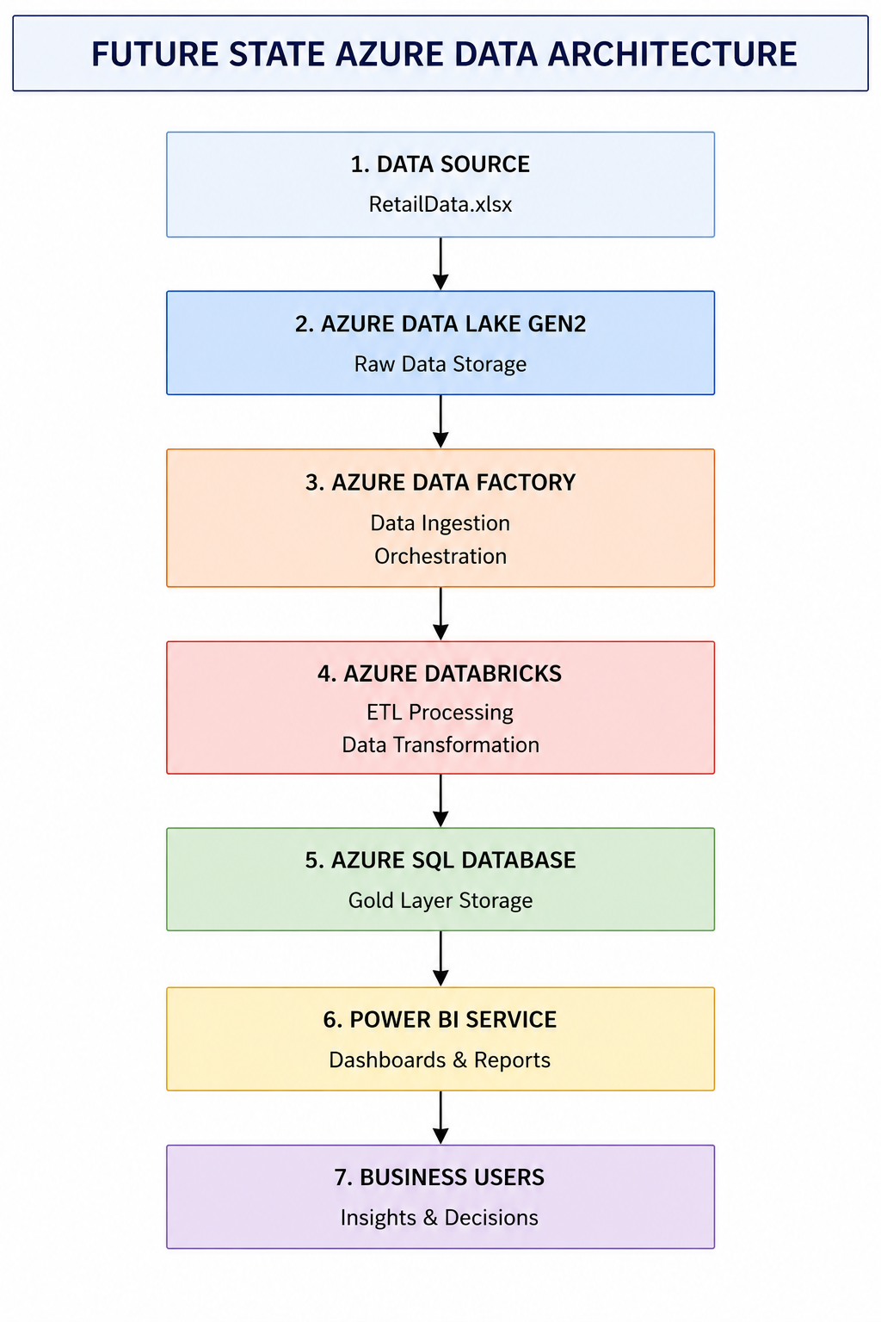
Figure 12.1: Future State — Enterprise Azure Data Engineering Architecture

12.2 Azure Component Overview
Azure Service | Pipeline Role | Capabilities Enabled
Azure Data Lake Gen2 | Bronze + Silver + Gold Storage | Hierarchical namespace, RBAC security, petabyte-scale storage, Parquet/Delta format support
Azure Data Factory | Orchestration & Ingestion | Scheduled pipeline triggers, 90+ connectors, copy activity for data ingestion, dependency management
Azure Databricks | Transformation Engine | Apache Spark-based processing, Delta Lake support, notebook-based data engineering, MLflow integration
Azure SQL Database | Gold Layer Serving | Managed relational database, T-SQL querying, Direct Query Power BI connectivity, automatic backups
Power BI Service | Business Intelligence | Cloud-based dashboard hosting, scheduled refresh, row-level security, collaboration features
Azure Key Vault | Security & Secrets Management | Secure storage of connection strings, API keys, and credentials; integrated with ADF and Databricks
Azure Monitor | Observability | Pipeline execution monitoring, alerting on failures, performance metrics, cost tracking
Table 12.1: Azure Future State — Component Architecture Summary

The Azure architecture preserves the three-layer Medallion Architecture framework, mapping Bronze, Silver, and Gold data to corresponding container hierarchies within Azure Data Lake Gen2. Azure Data Factory orchestrates all pipeline execution, scheduling Bronze layer ingestion jobs and triggering Silver and Gold transformation runs in Databricks upon successful ingestion completion. The Gold layer dimensional model is served from Azure SQL Database, providing optimised query performance for Power BI Direct Query connectivity and enabling sub-second dashboard refresh times at scale.

13. Technology Stack
The following table documents all technologies employed in the project, their roles within the pipeline, and the rationale for their selection:

Technology | Version | Role | Justification
Python | 3.10+ | Core programming language | Dominant language for data engineering; extensive library ecosystem; cross-platform compatibility
Pandas | 2.x | Data manipulation & transformation | Industry-standard DataFrame library; comprehensive API for all required transformation operations
NumPy | 1.24+ | Numerical computation | Vectorised numerical operations; foundational dependency for Pandas; efficient array processing
Microsoft Excel (.xlsx) | N/A | Source data format | Real-world retail data commonly stored in Excel; demonstrates handling of business-typical formats
Power BI Desktop | Latest | Business intelligence & dashboards | Microsoft's leading BI tool; DAX measure creation; direct integration with Azure SQL and CSV sources
Draw.io / Lucidchart | N/A | Architecture diagram design | Professional-grade diagramming tools for pipeline architecture and data flow documentation
GitHub | N/A | Version control & portfolio hosting | Industry-standard source code management; enables collaborative review and professional portfolio visibility
Azure (Future State) | Cloud | Enterprise cloud platform | Microsoft's leading cloud platform; native Power BI integration; comprehensive managed data services
Table 13.1: Project Technology Stack Summary

14. Challenges Encountered & Solutions Implemented
The execution of this project presented several technical and analytical challenges that required careful problem-solving and iterative refinement. The following section documents the primary challenges encountered and the solutions that were implemented to overcome them.

14.1 Data Quality Complexity
Challenge: The raw dataset exhibited multiple simultaneous quality defects across different fields — missing values, duplicates, inconsistent categories, and invalid entries — requiring a carefully sequenced multi-step transformation logic to ensure that each operation did not inadvertently introduce new quality issues or interfere with the correctness of subsequent transformations.
Solution: A strictly ordered transformation pipeline was designed with explicit validation checkpoints at each stage. The record count and key statistical metrics were logged before and after each transformation step to confirm that each operation produced the expected outcome and did not yield unexpected side effects.

14.2 Dataset Integration Challenges
Challenge: The two transaction datasets (retail_data1 and retail_data2) exhibited subtle differences in data entry conventions despite sharing an identical schema, including minor variations in categorical field values and date format representations that were not immediately apparent upon initial inspection.
Solution: A comprehensive data profiling step was introduced at the beginning of the Silver layer processing to systematically enumerate all unique values in categorical fields and detect format variations in date fields across both source datasets prior to the application of standardisation logic.

14.3 PII Masking Design
Challenge: Designing PII masking logic that adequately protects individual privacy whilst preserving sufficient structural information for legitimate analytical purposes (such as email domain analysis) required careful consideration of the balance between privacy protection and analytical utility.
Solution: A domain-preserving email masking strategy was adopted, in which only the local part of the email address (before the @ symbol) is masked whilst the domain is retained. For telephone numbers, a suffix-preserving strategy was implemented, retaining only the final three digits. These approaches were validated against the analytical requirements to confirm that the masked data remained fit for its intended analytical purposes.

14.4 Dashboard Design & User Experience
Challenge: Designing Power BI dashboards that effectively communicate complex multi-dimensional retail performance data to audiences with varying levels of data literacy — from executive stakeholders who require high-level summaries to analytical team members who require granular supporting detail — required significant design iteration.
Solution: A layered information architecture was adopted, with each dashboard presenting headline KPI cards at the top followed by progressively more granular supporting visualisations. Consistent colour coding, standardised chart types, and clear axis labelling were applied across all dashboards to minimise cognitive load and accelerate insight extraction.

14.5 KPI Definition & Validation
Challenge: Establishing precise, unambiguous definitions for each KPI and validating computed values against independent calculations was essential to ensure that the KPI Engine produced reliable, trustworthy outputs.
Solution: Each KPI computation was implemented twice using independent code paths, and results were cross-validated before acceptance. KPI definitions were documented in formal business glossary format to eliminate ambiguity and ensure consistent interpretation by all stakeholders.

15. Project Outcomes

15.1 Technical Outcomes
The project successfully delivered the following technical outcomes:
- A fully functional, end-to-end Python data engineering pipeline implementing all three layers of the Medallion Architecture.
- Automated ingestion of retail transaction data from multi-sheet Microsoft Excel source files.
- Comprehensive data quality transformation logic addressing all identified data quality defects, reducing the raw dataset from 8,494 to 7,914 validated records.
- A dimensional data model comprising one fact table (fact_sales), three dimension tables (dim_product, dim_city, dim_date), and four pre-aggregated reporting tables.
- A KPI Engine computing six enterprise-level business performance metrics.
- Five interactive Power BI dashboards providing executive, revenue, product, category, and regional analytical perspectives.
- A documented future-state Azure enterprise architecture providing a clear cloud migration pathway.

15.2 Business Outcomes
- Total Revenue Quantified: INR 1.16 Billion in retail revenue accurately identified and validated through the pipeline.
- Data Quality Enforced: 494 duplicate records and 86 invalid quantity records eliminated, materially improving the accuracy of all reported metrics.
- PII Protected: All customer personally identifiable information (email addresses and telephone numbers) masked in the analytical environment.
- Actionable Insights Delivered: Five data-driven business insights identifying the top-performing city (Chennai), top product (Laptop), category concentration risk, and customer repeat purchase patterns.
- Reporting Automation: Manual, ad-hoc data processing eliminated and replaced by an automated, repeatable pipeline.

15.3 Professional Development Outcomes
- Demonstrated end-to-end data engineering project delivery capability from architecture design through implementation to stakeholder reporting.
- Applied industry-standard Medallion Architecture in a practical retail analytics context.
- Gained practical experience in Python-based ETL development, dimensional modelling, KPI engineering, and Power BI dashboard development.
- Produced a professional-grade portfolio artefact suitable for presentation to hiring managers, data engineering recruiters, and corporate evaluation boards.

16. Conclusion
This report has presented a comprehensive technical and business documentation of the Retail Data Engineering Pipeline — a professional portfolio project designed to demonstrate the full spectrum of data engineering competencies required in modern enterprise environments.
The project successfully addressed a real-world data quality and analytical reporting challenge encountered by retail organisations operating with fragmented, multi-source transactional data. Through the systematic application of the Medallion Architecture framework, the raw retail dataset — comprising 8,494 records distributed across two transaction batches and a product reference sheet — was progressively transformed from a collection of quality-deficient, analytically unusable raw files into a governed, validated, and commercially actionable analytical asset.
The Silver layer transformation pipeline eliminated 494 duplicate records and 86 invalid entries, standardised categorical and temporal fields, imputed missing price values from reference data, applied PII masking controls to protect customer privacy, and derived revenue calculations to enable accurate financial reporting. The resulting clean dataset of 7,914 validated transactions was subsequently modelled into a dimensional star schema in the Gold layer, generating fact tables, dimension tables, and pre-aggregated reporting datasets optimised for business intelligence consumption.
The KPI Engine derived six headline business metrics from the Gold layer outputs, confirming total retail revenue of INR 1.16 Billion across 7,914 orders generated by 1,960 unique customers at an average order value of INR 147,080. Chennai was identified as the highest-performing geographic market and Laptop as the highest-revenue individual product.
The five Power BI dashboards developed on top of the Gold layer provide retail stakeholders with an interactive, multi-perspective analytical platform that replaces manual reporting with automated, reliable, and visually compelling business intelligence. These dashboards enable evidence-based decision-making at both the executive strategic level and the operational commercial level.
Looking ahead, the documented Azure future-state architecture provides a clear and technically sound migration pathway from the current local implementation to an enterprise-grade cloud data platform, ensuring that the pipeline's design patterns and analytical outputs will scale effectively as data volumes and organisational analytical demands grow.
This project demonstrates proficiency across the full data engineering value chain — from data ingestion design and data quality engineering through dimensional modelling, KPI derivation, and business intelligence delivery — and stands as a substantive portfolio artefact reflecting the capabilities and professional standards required of a practising Data Engineer in a corporate environment.

17. Future Enhancements
The following enhancements are planned for subsequent iterations of the pipeline to extend its capabilities, scalability, and business value:

17.1 Real-Time Data Ingestion
The current batch-processing architecture processes data on a periodic basis from static Excel files. A real-time streaming ingestion capability using Apache Kafka or Azure Event Hubs would enable the pipeline to process transactions as they occur, providing business stakeholders with up-to-the-minute KPI updates and enabling real-time alerting on anomalous transaction patterns.

17.2 Azure Cloud Deployment
Migration of the full pipeline to the Azure cloud architecture described in Section 12 would deliver enterprise-grade scalability, managed infrastructure, automated monitoring, and native Power BI Service integration. This migration is the highest-priority enhancement for production deployment.

17.3 Delta Lake Implementation
Adoption of the Delta Lake open-source storage format within Azure Databricks would enable ACID transaction support on the data lake, time-travel queries for historical data analysis, and efficient incremental processing through Delta's change data capture capabilities.

17.4 Automated Pipeline Orchestration
Implementation of a workflow orchestration framework (Apache Airflow or Azure Data Factory) would enable fully automated, scheduled pipeline execution with dependency management, retry logic, failure alerting, and comprehensive execution audit logging.

17.5 Advanced Analytics & Machine Learning
Integration of machine learning models into the Gold layer would enable predictive analytics capabilities including demand forecasting, customer churn prediction, dynamic pricing optimisation, and product recommendation engines. These capabilities would significantly extend the analytical value of the pipeline beyond descriptive reporting.

17.6 Data Quality Monitoring Framework
Implementation of a continuous data quality monitoring framework using tools such as Great Expectations or Azure Purview would enable automated detection and alerting of data quality degradation across all pipeline layers, ensuring sustained analytical reliability over time.

17.7 Self-Service Data Catalogue
Development of a business-facing data catalogue integrated with the Gold layer dimensional model would enable non-technical business users to discover, understand, and self-serve analytical data assets without requiring data engineering team support.

References
The following references informed the design decisions, architectural patterns, and technical implementations documented in this report:

- Databricks. (2023). Medallion Architecture: Best Practices for Building a Lakehouse. Databricks Engineering Blog. https://www.databricks.com/glossary/medallion-architecture
- McKinney, W. (2022). Python for Data Analysis: Data Wrangling with Pandas, NumPy, and Jupyter (3rd ed.). O'Reilly Media.
- Kimball, R., & Ross, M. (2013). The Data Warehouse Toolkit: The Definitive Guide to Dimensional Modeling (3rd ed.). Wiley.
- Microsoft. (2024). Azure Data Factory Documentation. Microsoft Learn. https://learn.microsoft.com/en-us/azure/data-factory/
- Microsoft. (2024). Azure Databricks Documentation. Microsoft Learn. https://learn.microsoft.com/en-us/azure/databricks/
- Microsoft. (2024). Power BI Documentation. Microsoft Learn. https://learn.microsoft.com/en-us/power-bi/
- Microsoft. (2024). Azure Data Lake Storage Gen2 Documentation. Microsoft Learn. https://learn.microsoft.com/en-us/azure/storage/blobs/data-lake-storage-introduction
- Pandas Development Team. (2024). Pandas Documentation (v2.x). https://pandas.pydata.org/docs/
- NumPy Development Team. (2024). NumPy Documentation (v1.26). https://numpy.org/doc/stable/
- DAMA International. (2017). DAMA-DMBOK: Data Management Body of Knowledge (2nd ed.). Technics Publications.
- Reis, J., & Housley, M. (2022). Fundamentals of Data Engineering. O'Reilly Media.
- European Parliament. (2016). General Data Protection Regulation (GDPR) — Regulation (EU) 2016/679. Official Journal of the European Union.
- https://github.com/Rameshkn04/Retail-Data-Engineering-Pipeline.git

Appendix

Appendix A: Source Code Repository
The complete Python source code for this project — including Bronze ingestion scripts, Silver transformation pipeline, Gold dimensional modelling logic, and KPI Engine — is maintained in a structured GitHub repository. The repository is organised in accordance with professional data engineering project conventions.

Layer | Implementation File
Bronze Layer | Data/Bronze/USECASE - Data Engineering.xlsx
Silver Layer (ETL & Data Cleaning) | Code/retail_etl.py
Gold Layer (Star Schema & Aggregations) | Code/gold_layer.py
KPI Engine | Code/executive_kpis.py
Dashboard Layer | PowerBI/Retail_Data_Engineering_Dashboard.pbix
Monitoring & Logging | Logs/*.log
Documentation | README.md, Retail_Data_Engineering_Report.docx
Table A.1: Source Code Repository Structure

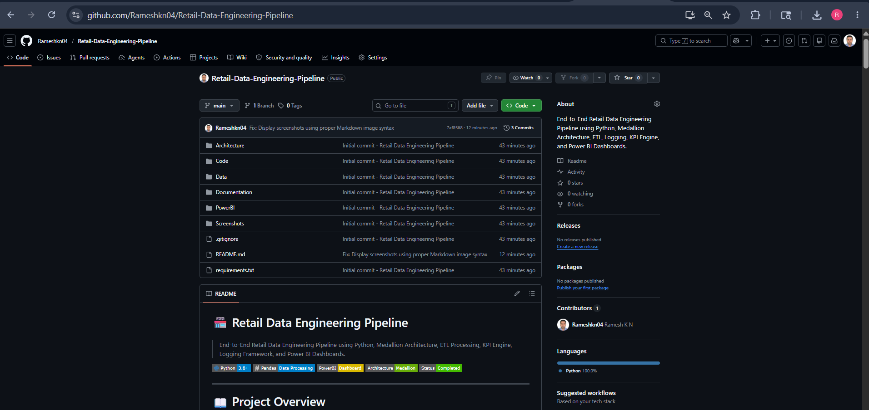

Appendix B: Architecture Diagrams
The following placeholder sections are reserved for the inclusion of all architecture diagrams referenced in the body of this report:


Figure B.1: Medallion Architecture — Detailed Layer Design


Figure B.2: Silver Layer — Complete Transformation Sequence

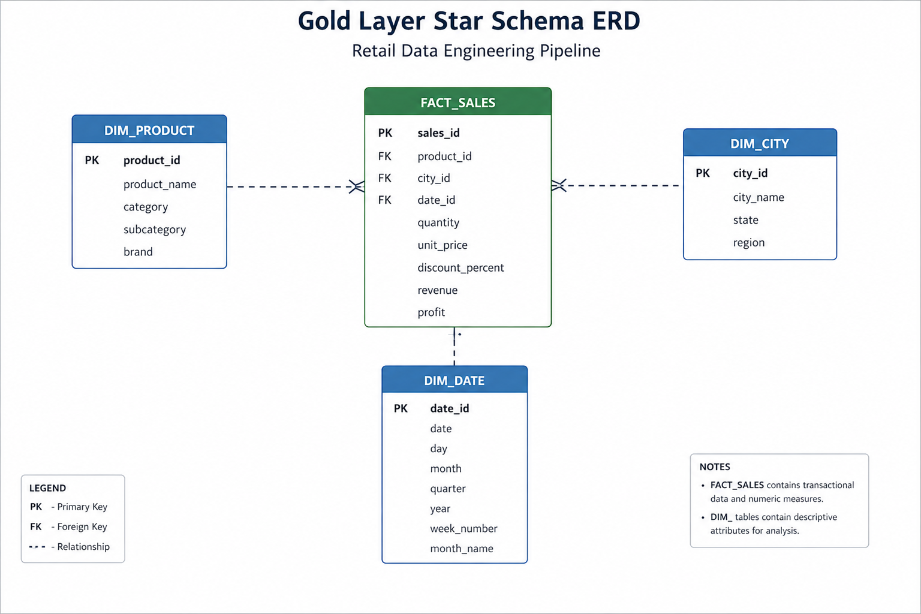
Figure B.3: Gold Layer — Dimensional Data Model (Star Schema)


Figure B.4: Azure Cloud Architecture — Future State Deployment

Appendix C: Dashboard Screenshots
Full-resolution dashboard screenshots are to be inserted into the following placeholders upon completion of Power BI development:


Figure C.1: Power BI Executive Summary Dashboard


Figure C.2: Power BI Revenue Trends Dashboard


Figure C.3: Power BI Product Performance Dashboard


Figure C.4: Power BI Category Analysis Dashboard


Figure C.5: Power BI Regional Analysis Dashboard

Appendix D: Data Quality Report
The following table provides a comprehensive record of all data quality issues identified during the assessment phase, the transformations applied, and the quantified outcomes:

Issue | Records Affected | Transformation Applied | Records Resolved | Outcome
Duplicates | 494 | drop_duplicates() | 494 | Eliminated
Invalid Quantity | 86 | Filter qty <= 0 | 86 | Excluded
Missing Prices | Variable | Reference join imputation | Most resolved | Imputed/Flagged
Category Variations | Multiple | str.strip().title() + mapping | All resolved | Standardised
Date Formats | Mixed | pd.to_datetime() | All resolved | Normalised
Email PII | 7,914 | Domain-preserving masking | 7,914 | Masked
Phone PII | 7,914 | Suffix-preserving masking | 7,914 | Masked
Table D.1: Data Quality Remediation Log

END OF REPORT | Retail Data Engineering Pipeline | Prepared by Ramesh K N | June 2026

